A POSSIBLE EARLY MEDIEVAL CROSS SLAB FROM CLONMORE, BREE
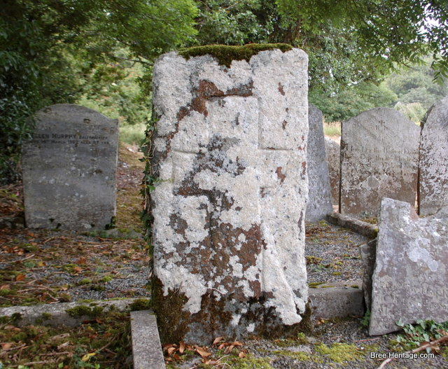
In the southern side of Clonmore graveyard, Bree, Co. Wexford stands a large, upright slab of stone that is noticeably different to the surrounding grave markers. It bears no written inscription and it has a much cruder finish than the other, mainly 18th and 19th headstones. Instead, one side of the slab contains a depiction of a Latin cross which has been carefully carved into the stone. Although such simple slabs are difficult to date, the style of the cross and the roughly hewn nature of the stone may indicate that it is of considerable antiquity. This would not be surprising as Clonmore represents an early church site that was probably established sometime between the 6th and 7th centuries AD.
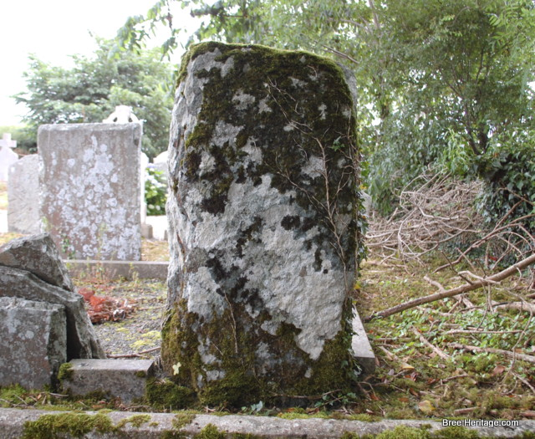The back of the Clonmore cross slab
Today evidence for Clonmore’s rich historic past includes the foundations of a simple nave and chancel church of possible 13th/14th century date, as well as a fine collection of 18th century headstones. A small granite font, of probable medieval date, is also associated with the church and is currently located in the garden of the parochial house.
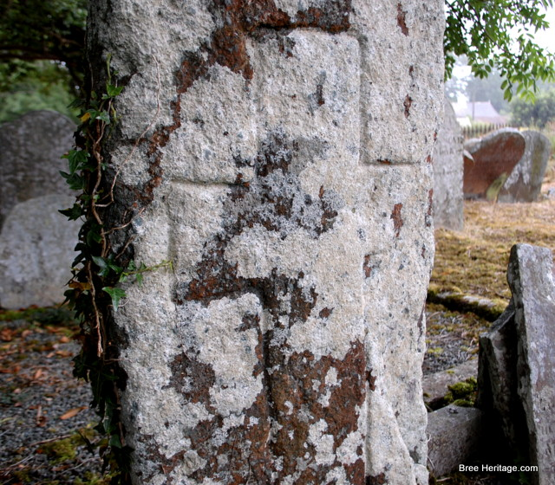Close up of the inscribed Latin cross at Clonmore
The possible early cross slab is situated in the southern side of the graveyard, where it has been re-erected over a relatively recent grave. It measures circa 1.12m tall by 0.58m wide and it appears to be fashioned out of locally sourced shale. A Latin cross has been inscribed on its eastern face and this measures circa 0.93m tall by 0.45m wide. Unfortunately one arm of the cross was damaged in the past, when a large chip was removed from the northern side of the slab.
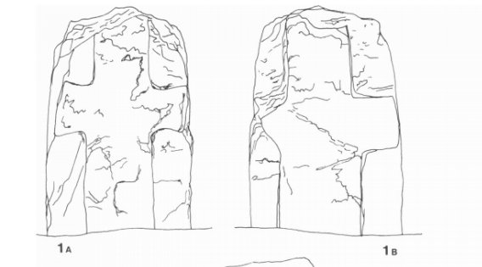A comparable cross slab from Clonmore, Carlow (after Harbison, 1991)
Such simple Latin crosses are hard to securely date, but parallels can be found at a number of other Early Christian sites. These include broadly similar cross designs from locations such as Labbamolga, Co. Cork, Kilgeever, Co. Mayo and St. Berrihert’s, Co. Tipperary. At Clonmore’s namesake in Co. Carlow, a cross slab of probably 9th or 10th century date is also comparable, while in county Wexford, Latin cross slabs are recorded at early medieval church sites such as Begerin and St. Dubhan’s (although these are thinner in design). Even closer to Clonmore is the medieval High Cross at Adamstown, which although different in form, has a cross outline that is quite similar to the Bree cross slab.
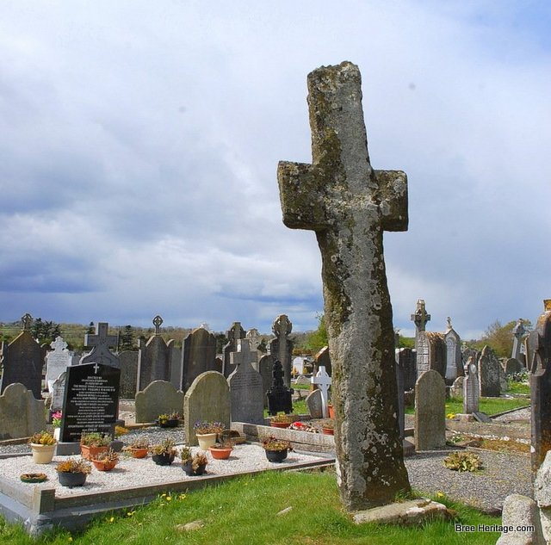Adamstown High Cross
This corpus of historical material, combined with Clonmore’s reputed early foundation, suggests that this newly identified cross slab could be of some antiquity and may even be early medieval in date (c. 400 – 1100 AD).

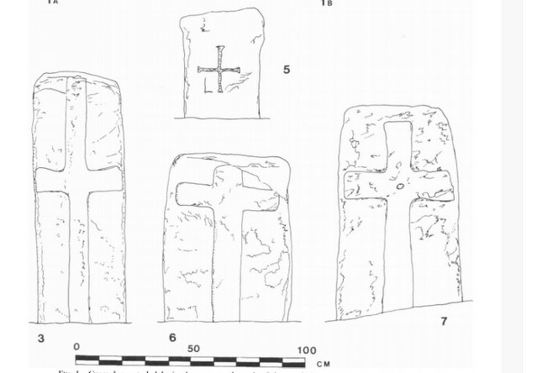More cross slabs from Clonmore, Carlow (after Harbison, 1991)

References
Harbison, P. (1991) ‘Early Christian Antiquities at Clonmore, Co. Carlow’ in Proceedings of the Royal Irish Academy: Archaeology, Culture, History, Literature, Vol, pp. 177-200
Moore, M.J. 1996. Archaeological Inventory of County Wexford, Dublin

